**Loan Analysis**

**Background**

Using the Universal Bank data, determine the factors that influence whether a customer takes out a loan.

**Resources**

Use the data set SCM 651 Homework 4 Universal Bank spreadsheet.

**Assignment**

**What’s due:**

Submit a logit, probit, and neural network analysis of loan acquisition behavior **before the live class in week 10**. Suggested length is 5 pages but should not exceed 10 pages, single-spaced, 12-point font.

This is a group assignment; each student should upload a copy of the assignment to the learning management system. The paper must be a Microsoft Word document. You should also submit the Excel spreadsheet with the prediction models and sensitivity analyses. Name the file HW4_Team# where # is your team number. Be sure to include the names of everyone on the team on the first page of the paper. Late assignments will not be accepted. Failure to follow directions will be penalized.

**Outline and grading criteria:**

1. Perform a logit and probit analysis of the variables that affect whether a customer takes out a loan. Consider only main effects (main variables, no moderating effects). Which variables are significant? How do the significant variables influence the likelihood of taking out a loan? Copy screen snapshots of your analysis in R to your report. (20%)

**Logit Analysis:**

The results from RStudio when running Logit Analysis using PersonalLoan as the Y-Variable, and all other fields as the X-Variables excluding ID and ZipCode Fields can be explained I the following manner. It is important to note that logit analysis stated that the X-Variabels of Age, Experience, and Mortgage fields were not statistically significant. Below is the interpretation of the statistically significant values:

CCAvg –This can be explained as the average of value of a credit card account increase, the probability of getting a personal loan increase.

CDAccount –This can be explained as the value in a CD Account increases, the probability of getting a personal loan increase.

CreditCard –This can be explained as if the applicant has an existing credit card with this bank, the chances of have a personal loan with the same bank decreases.

Education – This can be explained as the level of education of the applicant increases, the chances of getting a personal loan increases.

Family – This is explained as the size of a applicants family increases, the chances of getting a personal loan increases.

Income – As the income of an applicant increases, the chances of getting a personal loan increases.

Online – This can be explained as if the applicant uses online banking, the chances of getting a personal loan decreases

Securities Account – This can be explained as if the customer has a securities account with the same bank, then the probability of getting a personal loan decreases.

Below is a screenshot of our R-Studio output for Logit analysis:

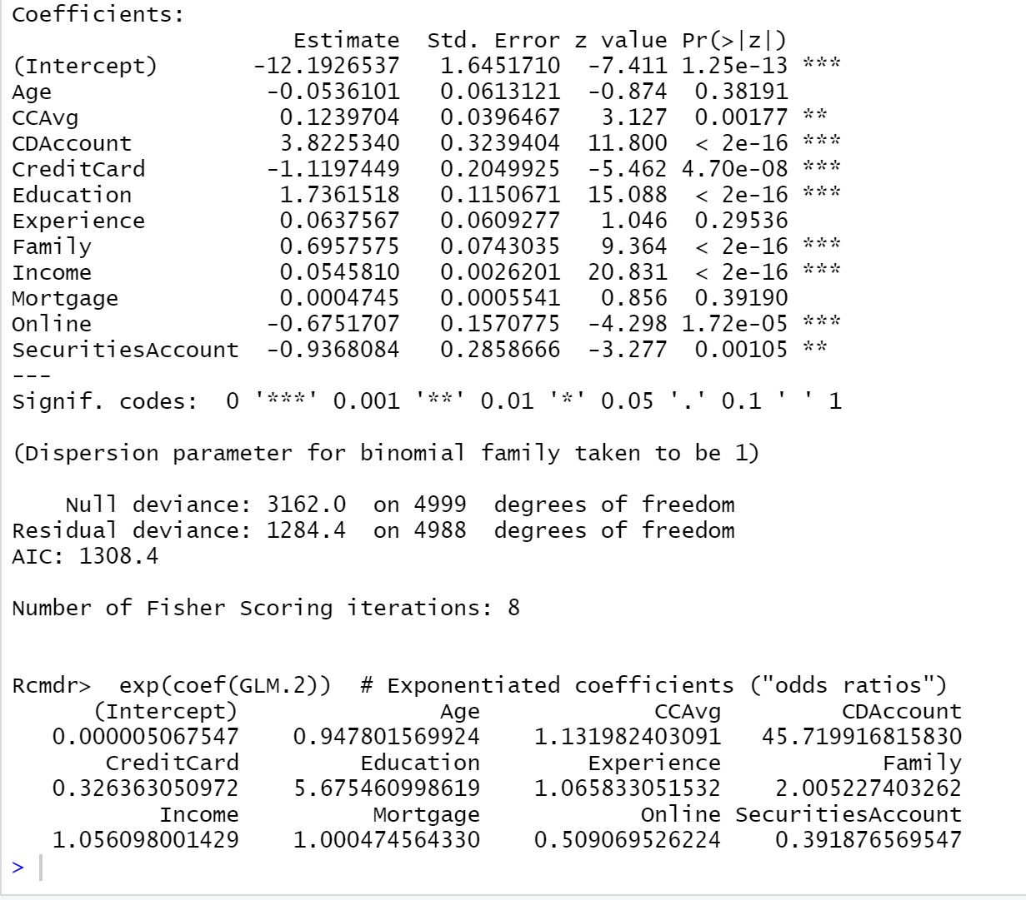

**Probit Analysis:**

When performing Probit analysis utilizing the same fields as Logit, R stated that the x-variables of Age, Experience, and mortgage were all not statistically significant, thus no further interpretation is authorized. The statistically significant variables of CCAVG, CDAccount,CredtitCard, Education, Family, Income, Online, and SecuritiesAccount can be explained the same way we interpreted those variables during Logit analysis. However, it is important that the amount of how those variables changes are different from the Logit output based off the values of their coefficients.

Below is a snapshot of our Probit Analysis Output:

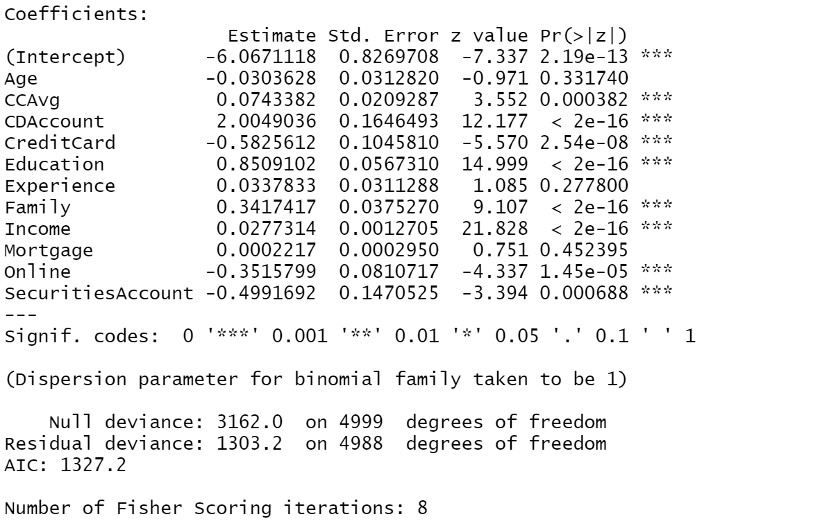

1. Add moderating effects (interactions of variables). Which interactions make sense conceptually? Which interactions are statistically significant? How do you interpret the coefficients on these variables? Copy screen snapshots of your analysis in R to your report. (20%)

Conceptually, the variables of Family interacting with CCAvg, and Education interacting with Income seems to make the most sense. The interactions of variables that make sense conceptually CCAvg and Family size. The more often an individual is using the credit card and carrying a balance and the larger the family size, the more likely that individual is to need and accept a personal loan. In addition, Education and Income also makes sense conceptually because an individual that has a higher income and a high education is more likely to accept a loan versus paying in full upfront because it is financially responsible to leave funds in a high interest savings account that gains interest and be able to qualify for a low interest or zero interest loan and pay it back over time without any cost to the applicant.

1. Create a final regression model with the variables that you feel are important (both main effects and interaction terms). Use the moderating effect that was significant and its two individual main effects. Create a spreadsheet prediction of the model. Perform a sensitivity analysis as seen earlier in the semester. Which variables have the greatest influence on the customers’ loan behavior (combined main effects and interaction effects)? Copy screen snapshots of your analysis in R to your report. (20%)

1. Perform a neural network analysis of the variables in part 3 above. Copy screen snapshots of your final neural network model in R to your report. (20%)

1. Create a prediction model of the neural network in part 4. Using the prediction model, perform a sensitivity analysis for the neural network model like the logit and probit sensitivity analysis. (20%)

Justify your answers. Provide a snapshot of output from your analysis in your final paper.

**Universal Bank Data Fields**

ID unique identifier

Personal Loan did the customer accept the personal load offered (1=Yes, 0=No)

Age customer’s age

Experience number of years of profession experience

Income annual income of the customer ($000)

Zip code home address zip code

Family family size of customer

CCAvg average spending on credit cards per month ($000)

Education education level (1) undergraduate, (2) graduate, (3) advanced/professional

Mortgage value of house mortgage ($000)

Securities does the customer have a securities account with the bank? (1=Yes, 0=No)

CDAccount does the customer have a certificate of deposit with the bank? (1=Yes, 0=No)

Online does the customer use internet banking facilities? (1=Yes, 0=No)

CreditCard does the customer use a credit card issued by Universal Bank? (1=Yes, 0=No)